Digestive Safety Built Into the Optimizer
Oct 11, 2026 · @CHARLEAU Célian

The thesis: make tolerance a state the optimizer learns, and ship sequences, not menus
The promise you can keep is not "no digestive issues". It is "digestive signals are expected, bounded, explained and used, and the dog's diet gets better because of them". That is also the promise that makes a user feel in control rather than lucky.
Today the optimizer answers "what is the best bowl?" against a static nutrient target. A gut is not a static target. Tolerance is dog-specific, dose-dependent and path-dependent: what a dog handles this week depends on what it ate last week. So the decision variable should become the menu sequence over the coming weeks, and the dog's tolerance should become a first-class state the optimizer learns and respects.
Five capabilities, usable as a checklist for any feature in this area:
- Predict. Before a menu ships, say what the stool will do and when, including cosmetic changes. An expected symptom is not an alarm.
- Bound. Never move the diet further than the dog's current evidence supports. Novelty has a visible budget.
- Attribute. Design every exposure so a reaction can be traced to a cause. Feedback updates beliefs per ingredient and per dose, with non-diet causes in the running.
- Retreat. Every menu ships with a precomputed, one-tap fallback. Stepping back is a normal move, not a failure.
- Grow. The known-good region expands over time and menu quality converges to the unconstrained optimum. The user watches that progress.
Two consequences for the product. First, GI risk becomes a KPI next to cost, time and love, with a visible price of caution. The user already knows how to tweak constraints and explore solutions, so the same control extends to digestion. Second, caution is temporary and shrinking by construction: constraints relax as evidence accumulates, so the long-run menu is the one the optimizer would have produced anyway. Nothing is lost, it is sequenced.
None of this needs new science. It is a known class of problem, learning under safety constraints, and every piece has a proven pattern: trust regions from optimization, additive-increase multiplicative-decrease from network congestion control, receding-horizon control, dose-escalation designs from phase 1 trials, and N-of-1 causal inference. Your unfair advantage is that the app already controls the experiment: what goes in the bowl, when the batch is cooked, how it is prepared and stored. No clinical study has that.
One more reframe. "My dog has a sensitive stomach" is one of the main reasons people move to home cooking. Handled well, digestion is not a liability to contain. It is an entry use case and an acquisition story.

A working model the algorithm can use: three timescales and the full lever map
Digestive reactions come in three timescales, and the right response differs for each. Confusing the second with the third is the most common and most costly mistake: a self-resolving adaptation gets treated as an intolerance, an ingredient gets removed, and menu quality drops for nothing.
Timescale | Mechanism | Typical signature | Right response
Hours (same day to next) | Mechanical, osmotic, secretory: fat load per meal, meal volume, lactose, osmotic supplements, a high fish oil or liver dose | Vomiting or regurgitation 1 to 6 h after a meal; urgency, greasy or loose stool within 12 to 36 h | Split meals, cap per-meal fat, dilute the dose. Never an ingredient removal.
Days (2 to 14) | Microbial adaptation to a new fermentable load: fiber type, resistant starch, legume oligosaccharides, protein reaching the colon | Softening of half a grade to one grade on days 2 to 5, more gas, resolving by day 7 to 14 with no change at all | Hold and watch, with the forecast shown. Retreat only if it deepens past a threshold or outlasts the window.
Weeks to months | Immune: adverse food reaction to a protein (beef, dairy, chicken, wheat, lamb, egg and soy are the most reported); chronic enteropathy | Recurrent soft stool, itch, ear or skin signs; does not track single ingredients cleanly | Vet-led 8-week elimination diet. The app's job is the record, not the diagnosis.
Beyond fiber, fat and protein, these are the levers that actually move stool, that your data does not model yet, and that the app already controls. Every row is usable now with a label or a rule; none needs new research.
Lever | Why it moves stool | To use it now
Fat per meal, not only per 1000 kcal | Acute tolerance is a per-meal load: a daily fat total split in three is tolerated where the same total in one is not. Miniature schnauzers, Yorkshire terriers and cocker spaniels risk pancreatitis on fat spikes. | Meal count and meal size become decision variables. Cap fat in g per kg metabolic weight per meal, tighter for predisposed breeds and any history.
Meal volume | Fresh food is about 3 times the mass of kibble for the same energy. A bowl three times bigger overnight causes regurgitation and "he drinks less". | Mass per meal relative to body weight as a feature; three meals a day during transition.
Fermentable oligosaccharides and lactose | Raffinose-family sugars in legumes and crucifers, fructans in chicory and inulin, lactose in dairy are not digested and ferment to gas and water. | A per-ingredient label (none, low, medium, high). Soaking with the water discarded, then boiling or pressure cooking, cuts legume oligosaccharides by roughly a third to a half.
Resistant starch from batch cooking | Undercooked starch, and cooked rice, potato or pasta cooled and stored, retrograde into resistant starch. Day 4 of a batch is more fermentable than day 1 with an identical recipe. Reheating reverses part of it. | Flag starch sources. Assistant rule: cook fully, reheat before serving. Later, a storage-age term in the risk model.
Fiber type, not only soluble vs insoluble | Moderately fermentable mixes (beet pulp, pumpkin, psyllium plus cellulose) give the best stool. Highly fermentable fiber (inulin, FOS) softens past a modest dose. Pure insoluble bulk firms and dries. | Four classes per ingredient: insoluble non-fermentable, soluble viscous, soluble fermentable non-viscous, mixed. A band per class in g per 1000 kcal.
Protein reaching the colon | Your read is right: cooked plant protein digests well and amino acid bounds are not the issue. The issue is co-passengers and excess. Legumes carry oligosaccharides and resistant starch; skin, tendon, gristle and bone carry poorly digested collagen and ash; protein well above need in sensitive large breeds raises putrefaction (ammonia, indoles, branched-chain fatty acids) and softens and smells. | Cut-level labels (lean, connective tissue, skin-on). A protein ceiling that engages while stool is soft. Cooking checks in the assistant.
Supplements | Zinc and magnesium salts irritate on an empty stomach. Fish oil above a starting dose loosens stool. Liver above about 5% of the diet by weight loosens stool and overloads vitamin A. Excess bone meal or calcium hardens and whitens stool. | Stagger supplements like ingredients. Start fish oil at a quarter dose. Cap liver. Minerals with food.
Food safety and storage | Cooked food kept chilled beyond 3 to 4 days, cooled slowly or reheated unevenly is a hidden cause that looks like intolerance. Kidney beans need a full boil; a slow cooker on low does not destroy their lectin. | Batch size tied to fridge days, freeze beyond. Cool within 2 hours. The assistant checks legumes. You already own these levers.
Moisture shift | Kibble is about 10% water, fresh food about 70%. Stool gets smaller, softer and less frequent, the dog drinks less. Cosmetic, expected, and scary when unannounced. | Pre-announce it. Size-adjust the "normal" stool score.
Non-diet confounders | Treats, scavenging, table scraps, stress (boarding, visitors, travel), heat, antibiotics, NSAIDs, deworming, vaccines, parasites, a water change, heat cycles. | A non-diet cause channel in the attribution model and a one-tap "anything else change?".
Dose, not binary. Most intolerances are dose-dependent: lactose, fat, oligosaccharides, resistant starch, liver. So what the app learns about an ingredient is a dose cap for this dog, never a ban. Caps keep the optimizer's search space and the user's KPIs; bans shrink both. A ban is reserved for a suspected immune reaction or the owner's own choice.
Priors before any feedback. Large and giant breeds have wetter stool and lower digestibility, so their normal is softer and their target score must be size-adjusted. Starch tolerance varies by breed: amylase gene copies are fewer in huskies, samoyeds and other ancient breeds. German shepherds are over-represented in sensitive digestion, miniature schnauzers in fat intolerance. Puppies, seniors, dogs with a GI history and dogs coming from one single formula start with smaller steps. Ten onboarding questions set the initial step size, the target score band and the per-meal fat cap.
Timing the models rely on. A solid meal leaves the stomach over 4 to 10 hours and whole-gut transit is about 1 to 1.5 days, longer in big dogs, so stool on day t mostly reflects meals from day t-1. Microbiota shift within days and settle over 1 to 2 weeks after a change. Those two numbers define the observation lag and the adaptation window used everywhere below.

The core mechanism: a tolerance passport and a trust region inside the optimizer
Replace "reference menu" with "known-good region" and "transition" with "trust region". Those two moves reconcile variety with safety and give the optimizer something concrete to compute.
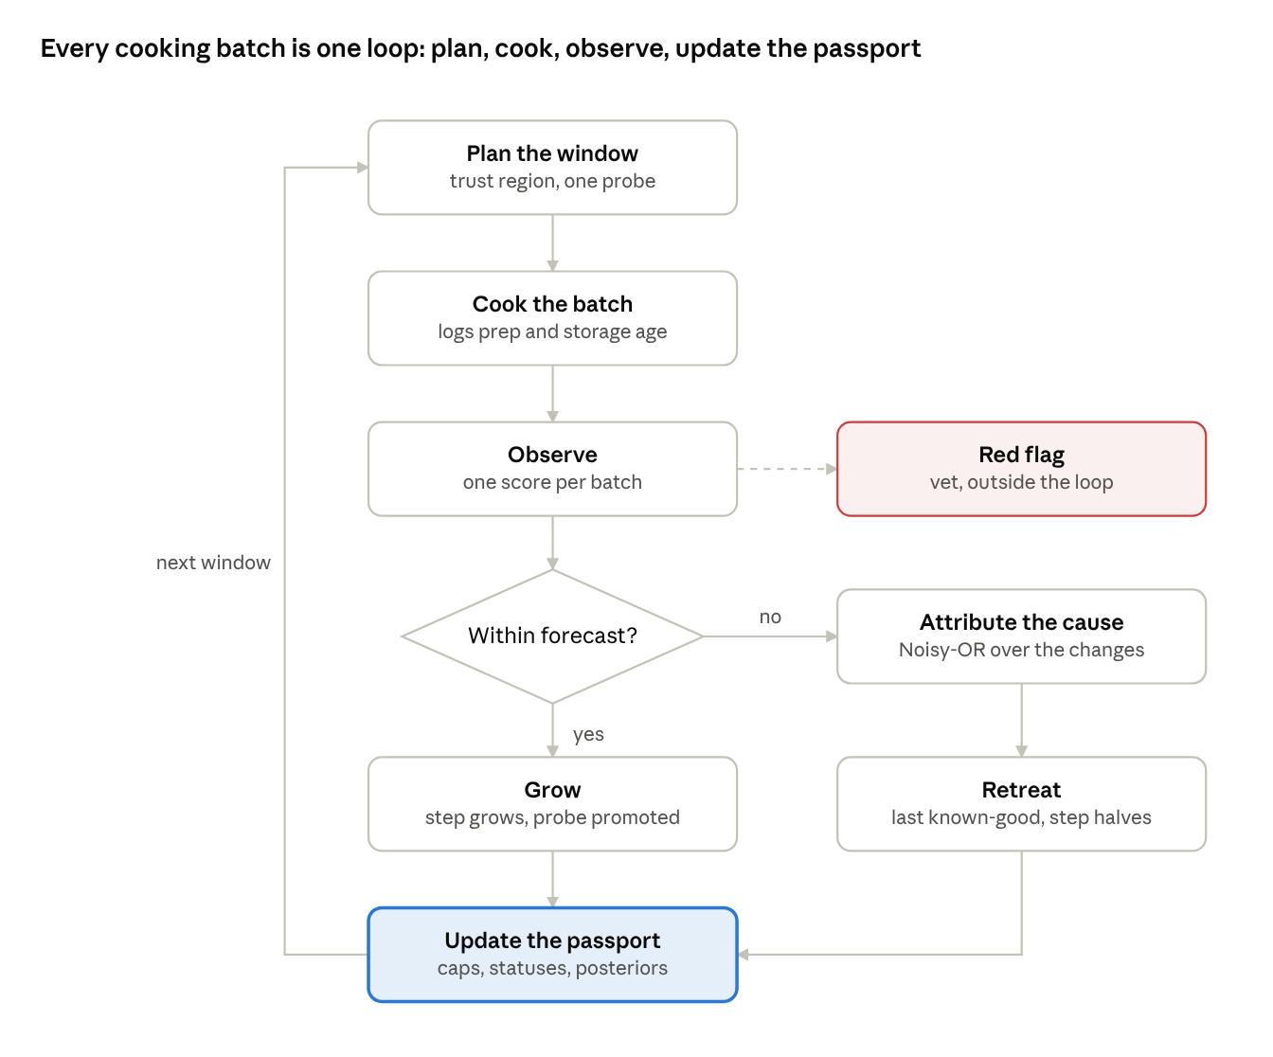
control loop · one cooking batch per turn, with the retreat path
A clean window grows the step and promotes the probe. A confirmed reaction is attributed, the menu retreats to the last known-good one, and the passport records a cap or a suspect. Red flags leave the loop for the vet.
The passport is the state. Per dog, for every ingredient and every GI feature (fat per meal, fermentable load, each fiber class, total protein, meal mass): a status among proven, probationary, untested, suspected, excluded; the highest proven dose; the evidence count; the last exposure date; and a posterior probability of intolerance. Plus three dog-level values: the current step size, the target stool band, and the last known-good menus. Everything below reads and writes this object.
Known-good region, not reference menu. Any menu whose ingredients are all proven at or below their proven doses, with GI features inside their proven bands, is known-good with high confidence. That is a box in feature space, not a recipe. Variety inside the box is free: the optimizer can rotate proteins, vegetables and starches week to week at no GI cost as long as it stays inside. Exploration happens only at the frontier, one step at a time. "Vary within the territory, explore at the frontier" is the rule that dissolves the variety-versus-stability worry.
A distance between two menus. The optimizer needs a number for "how brutal is this change". Define the distance between menus A and B as a weighted sum of absolute differences over GI features: fat per meal per kg metabolic weight, fat and protein per 1000 kcal, starch per 1000 kcal, each fiber class per 1000 kcal, fermentable oligosaccharide load, mass per meal, the energy fraction of ingredients absent from A, and supplement changes. Weights are the inverse of the tolerance scale on each axis, so 2 g of fat per 1000 kcal counts more than 2 g of insoluble fiber. Start the weights from the lever map and clinical heuristics; fit them later to whichever axes predict score drops across dogs. A weighted L1 distance is linear, so it drops into the current LP as a constraint.
Trust region with AIMD step control. Every window carries the constraint: distance from the last known-good menu at most the step size. After each window, a clean result grows the step by a fixed increment, a marginal result holds it, and a reaction halves it and returns the menu to the last known-good one or the midpoint between it and the failed one. This is TCP's congestion control, and it fits for the same reason: capacity is unknown, probing is cheap, overshoot is expensive. Two details matter. Steps are measured in distance, not in percent of the bowl, because a 25% kibble-to-fresh step can be tiny or huge depending on what the fresh part is. And growth is fast for an easy dog, so a robust gut reaches the unconstrained optimum in two or three windows and never feels the brakes.
Kibble is an ingredient. Put the kibble's guaranteed analysis into the ingredient table and give it a cap that shrinks window by window. The optimizer rebalances the fresh part around it, so the mixed bowl is complete at every step rather than only at the end. The first fresh menu is a bridge: the solution closest in distance to the kibble's profile that meets requirements. This also answers your open question about a ramp that goes wrong: raise the kibble cap one step back, hold a window, resume. Nothing to diagnose on a first retreat.
Core, rotation, probe. Structure every menu in three layers. A core of roughly 80% of energy, stable across weeks, from proven ingredients. A rotation layer of up to 20% for variety and the love KPI, also from proven ingredients. A probe of 5 to 10% of energy carrying exactly one untested ingredient or one feature step. Excitement lives in the rotation and the probe; stability lives in the core. Toppers are the natural probe vehicle: small, exciting, easy to withdraw.
The probe policy is dose escalation. One novel thing per window. The dose climbs across consecutive clean windows, 5%, 10%, 20%, then the optimizer's target. A window equals one cooking batch, rounded up to at least 3 days to cover the observation lag. This is the logic of phase 1 dose-finding, and it makes attribution trivial because only one thing changed. Which probe runs first is decided in the next section.
Receding horizon. The optimizer solves the next 4 to 6 windows at once, with transition constraints coupling consecutive windows and a novelty budget per window. It implements the first window, observes, updates the passport, re-solves. The user sees a plan for the coming month that adapts without surprising them. In LP terms: a mass variable per ingredient per window, the usual nutrient rows per window, a weighted L1 bound between consecutive windows, and a per-window cap on untested energy.
Two outputs per solve. Next to the KPIs, report the GI risk score and the price of caution: the gap in cost, time and love between this solution and the unconstrained one. The user can constrain the GI score like any other KPI, and the price of caution is what they get back, window after window, as the passport fills.

Turning stool into knowledge: feedback, attribution and re-challenge
The feedback loop is worth building only if it costs the user seconds and never blames the wrong thing. Both are design choices.
Signal design. Silence means fine: a day without a report is logged as within expectation. One tap, "something's off", expands to a 15-second form: stool score on a visual picker (Waltham 1 to 5 in half grades, or Purina 1 to 7), frequency, urgency, vomiting, gas, appetite, water, blood or mucus, and "anything else change?" with treats, scavenging, stress and medication as options. The expected curve sits on the same screen, so the user judges "within forecast?" themselves. Photo scoring with a vision model comes later and removes the only subjective step.
Lag and hysteresis. A single soft stool is noise, and reacting to it is how exclusion lists grow. Trigger on 2 of 3 consecutive days at or past the threshold, or on any red flag. Read stool against the meals of the previous day. Then classify the signature. At most one grade softer, on days 2 to 5 of a change, with no red flag, is adaptation: hold and watch. One and a half grades or more, persistence past day 7, or any red flag is a retreat. A small cumulative-sum rule does this in ten lines.
The batch is the trial arm. The user already cooks in batches of 3 to 5 days. Make that the exposure window: probes change only between batches, feedback aggregates per batch, and attribution works per batch. The experiment then costs the user nothing beyond what they already do.
Attribution: Noisy-OR with a confounder channel. For each window, list the candidate causes: the new ingredient, any dose step, any feature step such as fat per meal, a preparation deviation the assistant recorded (lentils not soaked, batch served on day 4), a supplement change, and the non-diet events the user ticked. Each candidate carries a probability of producing a reaction on its own, and the window's reaction probability is one minus the product of the complements. Priors come from the lever map, population base rates and the AI labels. A clean window lowers every probability present; a reaction raises each in proportion to its share of the blame. Keep one Beta distribution per ingredient and dose bin. This is implementable in a day, it is interpretable ("most likely: lentils at 15%, 62%; the fat step, 25%; the park outing, 13%"), and it is the model a hierarchical one pooled by breed and size replaces later without changing the interface.
Design for identifiability, and let the user pick the speed. One novel exposure per window makes attribution trivial. For users who want to go faster, allow adaptive group testing: introduce two or three low-prior ingredients together, and if a reaction occurs, bisect over the next windows. Offer "careful" and "faster" as a visible choice. Control is the point.
Re-challenge by value of information. A suspected ingredient is never banned. It is re-tested at half its previous dose after two clean windows, and the schedule is chosen by what it is worth. The optimizer already computes, for free, the shadow price of every dose-cap constraint: how much the user's KPIs improve if that cap is relaxed. Priority of a probe or a re-challenge is shadow price times the probability of tolerance from the passport. The passport therefore grows in the direction that matters for this user's own KPIs, and no window is spent on an ingredient the optimizer would not use anyway. The same rule picks the first probes among untested ingredients.
Guarding against exclusion-list inflation. This is the main long-run failure mode: a system that only removes converges to a boring menu for every dog. Four rules prevent it: caps rather than bans; scheduled re-challenge; posteriors that decay toward the prior after months without evidence; and the confounder channel, which absorbs the park outing instead of charging the lentils. The user sees the list and can overrule it.
Population learning, later. With a few thousand dog-weeks the same records support a hierarchical model: each dog's probabilities shrink toward its breed and size group, the distance weights are fitted to what actually predicts score drops, adaptation curves become forecasts, and interactions such as fat with fermentable fiber surface. Aggregate only; nothing leaves the household identifiable.

The safety track: what is never optimized or learned
A deterministic, versioned, vet-reviewed rule set runs beside the optimizer and outranks it. It never learns and no KPI can trade against it. It is what lets you launch before the learning track has data, and it is what the user is trusting when they stop worrying.
Red flags and escalation. Always visible and never "managed" by the app: blood in stool, red or black and tarry; vomiting more than twice in 24 hours, or any vomiting with lethargy; refusal of food beyond 24 hours (12 for a puppy); diarrhea beyond 48 hours (24 for a puppy or a senior); abdominal pain, bloating or unproductive retching, an emergency in deep-chested breeds; signs of dehydration; fever; a known toxin or foreign body. The wording is fixed: what to do now and who to call. Saying "call the vet" early and plainly is itself reassuring. Users learn the app will not stay quiet.
Hard caps the optimizer cannot cross. Fat per meal per kg metabolic weight, tighter for pancreatitis-prone breeds and any history. Liver at most about 5% of the diet by weight. A lactose cap on dairy. Legumes only soaked and boiled. Cooked bones, onion, garlic, grapes, xylitol and macadamia excluded, which you presumably enforce already. Raw feeding out of scope.
A precomputed retreat for every window. When the optimizer solves a window it also solves the retreat: the last known-good menu, or when none exists a stabilization menu with a clinical GI profile: lean protein, fully cooked rice or potato, a moderate mixed fiber such as pumpkin with psyllium, low fat, no probes, complete for at least two weeks in an adult. Its shopping list and batch size are already planned. One tap, zero latency, nothing to decide while anxious. For a dog still partly on kibble, "back to last week's kibble share" is the retreat. Keep a pantry version too: a short-term recipe from staples the user can cook tonight.
Special populations. Puppies: complete diets always, no bland diet beyond a day or two, half-size steps, vet thresholds pulled forward. Seniors: the same narrowing. A history of pancreatitis or hyperlipidemia: the tighter fat cap and no fat steps. A diagnosed chronic enteropathy, IBD or exocrine pancreatic insufficiency is not a transition problem: route it to a vet-supervised medical mode later, and today decline that case gracefully rather than serve a standard menu.
The record is a gift to the vet. Every window, dose, score and event forms a timeline the user exports in two taps. It is exactly what a vet asks for before an elimination diet and almost never gets. That turns your data from a liability into the reason a vet recommends the app. Language stays observational: the app notices, suggests and escalates; it does not diagnose. Have the wording and the thresholds reviewed by a veterinary nutritionist and version them.

Reassurance by design: how the user feels in control
The user feels in control when nothing that happens is a surprise and every signal visibly changes something. Six mechanisms deliver that, and most are cheap once the machinery above exists.
- The forecast card. Before each window: the expected drop in stool volume and frequency; the expected color from the ingredients (sweet potato and carrot orange, greens darker, liver and iron darker); "days 2 to 5 may be a touch softer, firm again by day 7"; and the two lines that matter most, "when we step back" and "when to call the vet". A predicted symptom that arrives on schedule is proof the app understands the dog.
- The visible if-then plan. Shown before anything happens: "if the score is 3.5 or more on two days, we return to Monday's batch; nothing for you to decide". The decision is pre-made, so the moment of worry carries no choice.
- GI risk as a KPI with a price of caution. A caution level the user sets, a GI score they can constrain, and the price of the current level in dollars, minutes and love percent. They watch that price shrink week by week. Most will pick "careful" when it costs 12 cents a day; the ones who pick "faster" have consented.
- Passport growth. "23 ingredients proven, 2 in trial, 1 resting until November 2." A progress bar, not a blacklist. The narrative is "we are mapping your dog together", and every clean window is a win the user can see.
- A closed loop in the same session. Every report produces a visible action within seconds: "thanks, next batch: lentils 15% to 8%, fat split over three meals, forecast updated". Feedback that visibly changes the plan is the strongest driver of continued feedback.
- Social proof from aggregates, once you have them. "87% of dogs starting from kibble see softer stool on days 2 to 4; 94% are normal by day 7." Numbers like these normalize the experience before it happens.
Two notes on language. Never "problem", always "signal". Never blame the cooking; attribute to the dish or the dose. And "sensitive stomach" deserves its own onboarding path that starts in stabilization mode and treats the first clean fortnight as the product's first win. That path is a feature and an acquisition channel, not a disclaimer.

Roadmap, metrics and the failure modes of this approach
Everything in the first phase rests on established knowledge and can ship in weeks. The second phase needs your own data, so its gate is a count of logged dog-weeks. The third phase holds the research bets, each with a fallback already running underneath it.
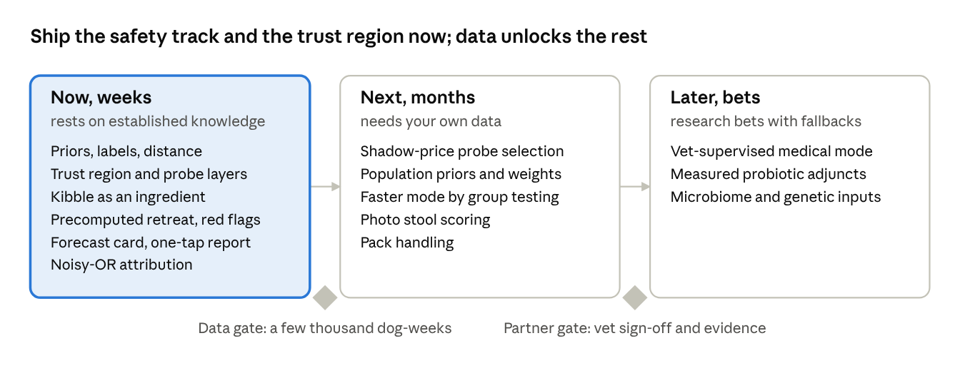
roadmap · three phases, two gates
The first phase ships on established knowledge. A few thousand logged dog-weeks unlock the learned priors of the second phase, and a vet partner with in-app evidence gates the bets of the third.
Process | Phase | Confidence | What it needs
Onboarding priors: initial step size, target stool band, per-meal fat cap | Now | Theory sufficient | Ten questions; breed and size tables
Ingredient GI labels: fiber classes, oligosaccharides, lactose, resistant starch, connective tissue, osmotic flag, allergen base rate, prep modifiers, stool color | Now | Theory sufficient | One LLM labeling pass over the ingredient table, reviewed by a nutritionist
Distance metric, trust-region constraint, core/rotation/probe layers | Now | Structure is sound; the weights are a first guess until fitted | LP rows; weights from the lever map
Kibble as an ingredient with a shrinking cap; bridge menu | Now | Theory sufficient | The kibble's guaranteed analysis
Meal count and size as decision variables; per-meal fat cap | Now | Theory sufficient | A per-meal view in the solver
Supplement staggering, quarter-dose fish oil start, liver cap | Now | Theory sufficient | Rules
Preparation and storage rules in the cooking assistant | Now | Theory sufficient | Batch size tied to fridge days; legume checks
Precomputed retreat per window; pantry recipe | Now | Theory sufficient | A second solve per window
Forecast card and visible if-then plan | Now | Timing is approximate; the retreat is the fallback | Templates from the lever map
One-tap feedback with the hysteresis rule | Now | Theory sufficient | A form and a ten-line rule
Noisy-OR attribution with Beta posteriors | Now | Useful with fallback: priors are guesses until data arrives | Priors from labels and base rates
Red-flag rule set; vet export | Now | Theory sufficient | Vet review of wording and thresholds
Shadow-price selection of probes and re-challenges | Next | Theory sufficient; value depends on feedback quality | The LP duals, which you already have
Population priors and learned distance weights | Next | Needs a few thousand dog-weeks | Aggregate records
Faster mode by adaptive group testing | Next | Theory sufficient; UX risk | Window bookkeeping
Stool photo scoring | Next | Published models exist; validation varies | A vision model; consent
Personalized adaptation-curve forecasts | Next | Needs data | Aggregate records
Pack handling: per-dog passports, shared core from their intersection | Next | Theory sufficient | A solver change
Vet-supervised medical mode: elimination diets, chronic enteropathy | Later | Research bet | Vet partners; regulatory review
Probiotic or prebiotic transition adjuncts, measured in-app | Later | Evidence modest; your N-of-1 records can settle it | A supplier
Microbiome and genetic inputs such as amylase copies | Later | Research bet | Partners
What to measure from day one. Share of transitions completed without a retreat. GI events per dog-week and days from retreat to recovery. Median stool score and its variance per dog. Attribution precision: the share of suspected ingredients confirmed on re-challenge. Passport growth in proven ingredients per dog per month. The price of caution over time, which should approach zero within six to eight weeks for a typical dog. Reports per window. Thirty-day retention of transitioning users. Vet escalations per hundred dogs, and how many were warranted.
Failure mode of this approach | Mitigation
Adaptation treated as intolerance | The signature rule, the forecast on screen, hold-and-watch as the default
Over-attribution to ingredients | The confounder channel, scheduled re-challenge, caps instead of bans
Exclusion-list inflation | Posteriors decay toward the prior; shadow-price re-challenge; the user can overrule
Feedback fatigue | Silence means fine; windows aligned to batches; a visible action after every report
Eager users bored by small steps | Careful versus faster mode; the step grows quickly when windows are clean
Puppies and seniors boxed in | Smaller steps but always complete diets; vet thresholds pulled forward
A pack held back by its most sensitive dog | Shared core from the intersection of passports; probes per dog
Preparation deviations invisible to the model | The assistant records what was actually done, including storage age
False reassurance | The safety track outranks everything and red flags are never softened

Appendix: implementation sketch and reference numbers
Optimizer terms. Keep every existing nutrient row per window. Index windows by t and ingredients by i, with x the grams per day, e the energy density, E the daily energy, and kibble one of the i. Add four things.
The trust region, with features f linear in x (fat per 1000 kcal, fat per meal, each fiber class, starch, oligosaccharide load, protein, mass per meal) and weights w from the lever map:
\sum_k w_k \,\bigl|\, f_k(x_t) - f_k(x^{\mathrm{good}}) \,\bigr| \;\le\; \delta_t
The probe budget: untested energy at most a fraction of daily energy, and at most one untested ingredient, enforced with one binary per untested ingredient or by solving once per candidate probe:
\sum_{i \in U} e_i\, x_{t,i} \;\le\; \varepsilon_t\, E_t, \qquad \bigl|\{\, i \in U : x_{t,i} > 0 \,\}\bigr| \;\le\; 1
Learned dose caps, and the GI risk score shown as a KPI and optionally bounded: an energy-weighted sum of per-ingredient intolerance probabilities plus feature penalties:
x_{t,i} \le \mathrm{cap}_i, \qquad \mathrm{GI}_t = \sum_i p_i(x_{t,i})\, \frac{e_i\, x_{t,i}}{E_t} \;+\; \sum_k g_k\bigl(f_k(x_t)\bigr)
The step-size update after each window, with b around one half:
\delta_{t+1} = \begin{cases} \min(\delta_{\max},\; \delta_t + a) & \text{clean} \\ \delta_t & \text{marginal} \\ \max(\delta_{\min},\; b\,\delta_t), \quad x^{\mathrm{good}} \leftarrow x_{t-1} & \text{reaction} \end{cases}
Attribution update. Candidates c in the window carry probabilities q, and the reaction probability is one minus the product of (1 − q). A clean window adds one "no reaction" observation to each candidate's Beta. A reaction adds a fractional "reaction" observation to each candidate equal to its share of the total, q divided by the sum of the q. Dose bins keep separate Betas so a cap, not a ban, falls out.
Probe priority. For each untested or suspected ingredient, priority equals the dual value of its cap constraint times the probability it is tolerated at the next dose, optionally times its love score. Run the highest-priority probe in the next window.
Ingredient GI attribute schema. One labeling pass fills this; a nutritionist reviews the high-impact rows.
Attribute | Values | Used by
fat per 100 g | number | per-meal fat cap, distance
fiber by class per 100 g | insoluble, soluble viscous, soluble fermentable, mixed | fiber bands, distance
oligosaccharide load | none, low, medium, high | fermentable load, priors
lactose | none, low, high | dairy cap, priors
resistant starch potential | none, low, high | storage rule, distance
connective tissue | lean, moderate, high | protein-to-colon term
osmotic flag | yes, no | supplement staggering
allergen base rate | per 1000 dogs, from published reports | attribution priors
prep modifiers | soak, pressure cook, drain fat, cook fully, purée | assistant checks; priors adjust when done
storage sensitivity | days | batch rules
stool color effect | none, orange, green, dark, red | forecast card
intolerance prior | Beta(alpha, beta) | attribution
Reference numbers. Approximate, from the veterinary nutrition literature and food safety guidance; verify the medium-confidence rows with your veterinary nutritionist before they become thresholds.
Quantity | Value | Confidence
Ideal Waltham score | 2 to 2.5 of 5, half grades | High
Ideal Purina score | 2 of 7 | High
Observation lag | stool reflects the previous day's meals; whole-gut transit 1 to 1.5 days | High
Adaptation window | softer on days 2 to 5, resolved by day 7 to 14 | Medium, varies by dog
Microbiota settling after a change | 1 to 2 weeks | Medium
Retreat trigger | 2 of 3 days at 1.5 grades or more above target, or any red flag | Design choice, tune on data
Probe dose ladder | 5, 10, 20% of energy, then the target | Design choice
Diet-level fat ranges | low-fat GI diets about 6 to 10% of dry matter; maintenance diets 10 to 20% | High for diets; a per-meal cap must be derived from these and learned
Liver cap | about 5% of the diet by weight | Medium, practice-based
Fresh food mass versus kibble | about 3 times for the same energy | High
Moisture | kibble about 10%, fresh about 70% | High
Cooked food chilled | 3 to 4 days; cool within 2 hours; freeze beyond | High
Legume oligosaccharide cut by soaking plus boiling | roughly a third to a half | Medium
Most reported canine food allergens | beef, dairy, chicken, wheat, lamb, soy, egg | High
Elimination diet length | 8 weeks | High
Large and giant breeds | wetter stool, lower digestibility; size-adjust the target | High

